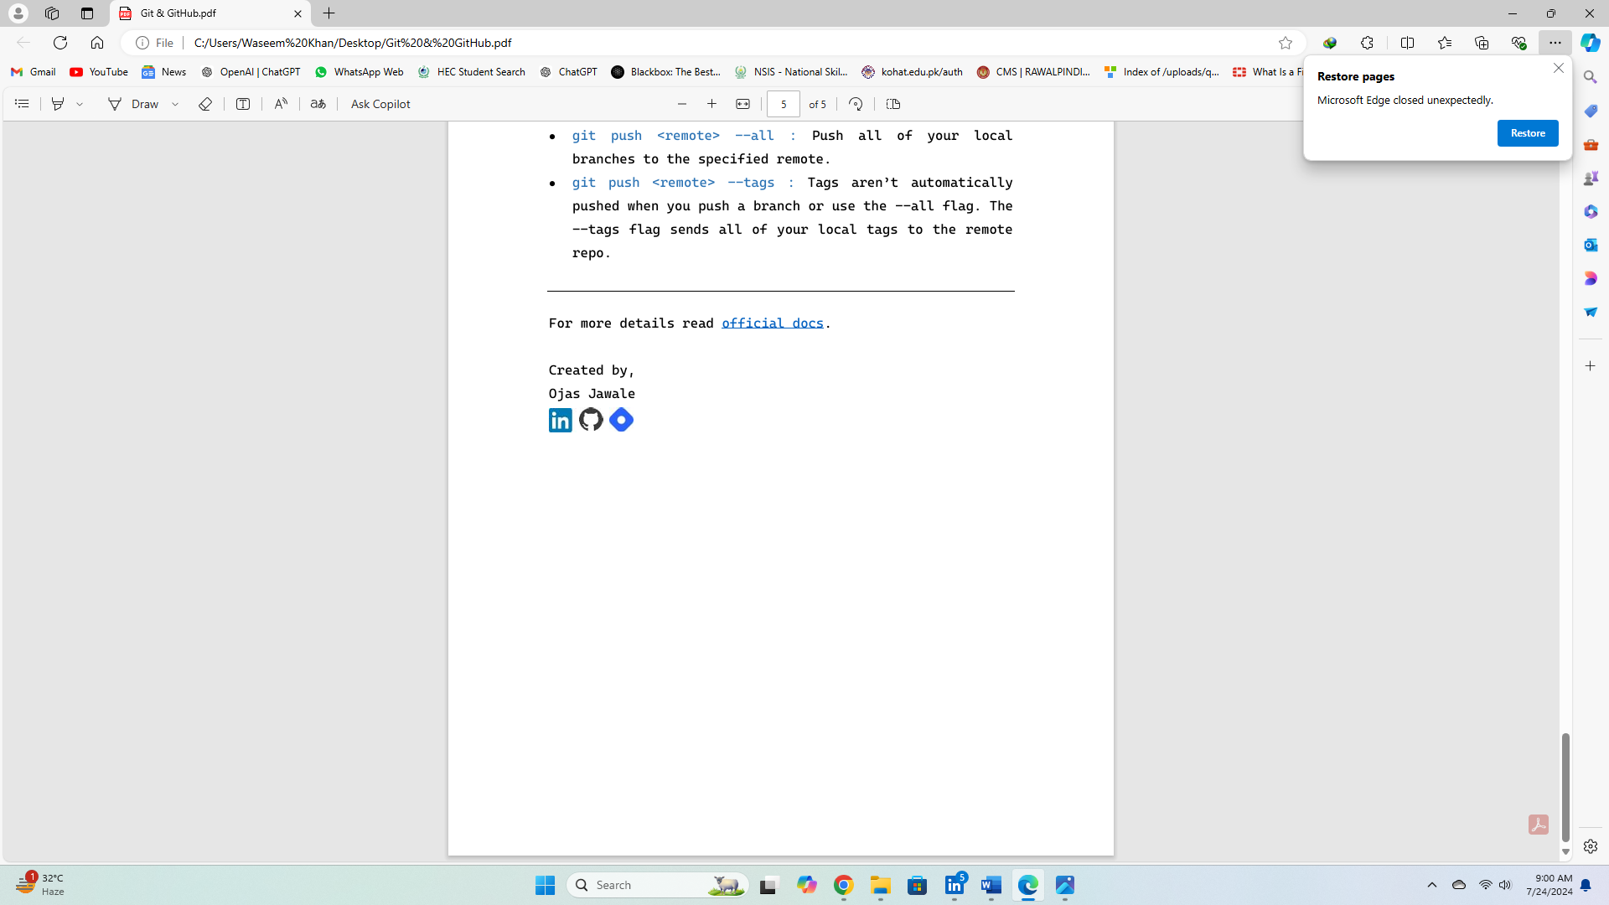

**Waseem Khan Dawar**

Linux

Basics (03)

Editor

Commands

types of editors in Linux:

there are mainly two editors in Linux.

1. Vim/vi

2. Nano

Note: We will use Vim/vi Editor in this at this moment.

1.Command to open file with editor in cli Linux (read only mode):

* vim [filename]
* vi [filename]

2.Command to open Editor mode in an editor (write and read mode):

* i

3.commad use to exit editor mode:

* esc (Button from keyboard)

We will follow the following sequence in file editing!

1. Save mode.

2. Insert mode.

3. Command mode

1. Save mode:

Note: Make sure to press ‘esc’ to exit the editor mode otherwise you will not able to apply the below commands.

1. Command use to save the file after editing:

* :w

2.Command use to quit the file:

* :q

3.Command use to save and quit the file but not forcefully:

* :wq

4.Command use to save and quite the file forcefully:

* :wq!

2. Insert Mode:

1. Command use to insert into a file (write and edit mode):

* i

2.Command use to go to the end of a line:

* A

3.Commad use to go to the start of line:

* I

4.Command use to add line above the current line:

* O

5.Command use to add line below the current line:

* o

3.Command mode:

1.command use to go to the top of a file:

* gg

2.Command to go to the bottom of the file:

* shift (from keyboard) + g

3.command to number (numbering lines) the lines in the editor:

* :set number

Note: n can be any number.

4.Command use to go the specific line:

* :n

5.Command use to copy the specific line:

* yy

6.Command use to copy multiple lines

* nyy

7.command use to paste the line/lines:

* p

8.command use to paste the lines multiple times:

* npp

9.command use to delete the line:

* dd

10.command use to delete multiple lines:

* ndd

11.command use to undo the line:

* u

12.command use to redo the line:

* shift (from keyboard) + r

13.command use to search for specific word:

* /word

**Created By,**

**Waseem Khan Dawar**

